“Given for You”
CONFIRMATION/YOUTH RETREAT
April 27-29, 2018

Let’s go to Camp Stony Glen (near Thompson, Ohio) for a spring retreat. Both the confirmation class and youth are invited. In addition, we are opening this retreat to other area churches as well. It’s going to be a blast! Using the theme, “Given for You,” the confirmation class will study the Lord’s Supper in their sectionals while the youth have a special topic of their own. There will also be plenty of time for outdoor recreation, camp fires, group games, meals, and more. A packing list will come out later for all those who have registered.
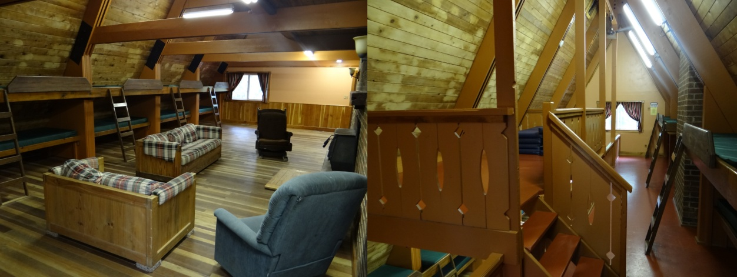
Registration for this event can be completed by doing the following:
- Fill out the form below. Keep the top and return the bottom portion to your pastor.
- Fill out the medical release form that is attached and return to your pastor.
- Pay the registration fee of $50 for each child which covers the whole weekend. If you write a check, make it out to “Zion Lutheran Church.” Write “retreat” on subject line.
- Chaperons are needed. Join us. You won’t regret it.

Any medications should be given to your Pastor/adult chaperon with a note attached detailing how and when the medicine should be taken. This includes common pain and cold medicine or tablets. We will be ending our retreat on Sunday at Holy Cross Lutheran Church in Madison (3050 McMackin Rd, Madison, OH 44057). Church starts at 10:00 a.m. followed by a lunch with the congregation. You will return following lunch or pickups can be arranged at Holy Cross. Registration is limited to the first 50. So get your forms in right away and reserve your spot.

---------------------------------------------------------------------------------------------------------------------
FILL OUT THIS BOTTOM SECTION AND RETURN TO PASTOR
Name- | Age/Grade
Address- | City, State, Zip
Parent/guardian signature | List any special needs here-
Medical Release attached? Yes No | Keep top portion of permission form.
Registration Fee – $50

